1. Problem Statement
Evaluate a sample password string against minimum length and simple character rules (like containing a number).
2. Objectives
- Use string len() and simple loops to check password rules.
- Display clear feedback on why a password failed.
3. Algorithm
- Start.
- Read password string.
- Check if length is at least 6 characters.
- Check if it contains at least one number digit using a loop.
- Print validation result.
- Stop.
4.Flowchart
[Start]
--> [Input Password String]
--> [Check Length: Is length >= 6?]
--> [Loop through characters to check if any digit (0-9) exists]
--> {Are both Length >= 6 AND Digit Present?}
├── Yes --> [Print: Password is VALID] --> [Stop]
└── No --> [Print: Password is INVALID with specific error logs] --> [Stop]
5. Psesudo code
START
PRINT "Enter password to validate:"
READ pwd
has_number = FALSE
FOR each character c in pwd DO
IF c is a digit ('0' to '9') THEN
has_number = TRUE
ENDIF
ENDFOR

IF length(pwd) >= 6 AND has_number == TRUE THEN
PRINT "Password is VALID."
ELSE
PRINT "Password is INVALID. Must be >= 6 chars and contain a number."
ENDIF
STOP
6. Python Source Code
print("=== Password Validation System ===")

password = input("Enter your password: "

length_ok = False
if len(password) >= 6:
length_ok = True

has_digit = False
for char in password:
if char >= '0' and char <= '9':
has_digit = True
break

if length_ok and has_digit:
print("\nResult: Password is VALID and strong enough.")
else:
print("\nResult: Password is INVALID.")
if not length_ok:
print("- Error: Password must be at least 6 characters long.")
if not has_digit:
print("- Error: Password must contain at least one number digit (0-9).")
7. Test Cases & Output Log
- Test Case: Password = abc1234 $→$ Output: Valid.
- Log:
=== Password Validation System ===
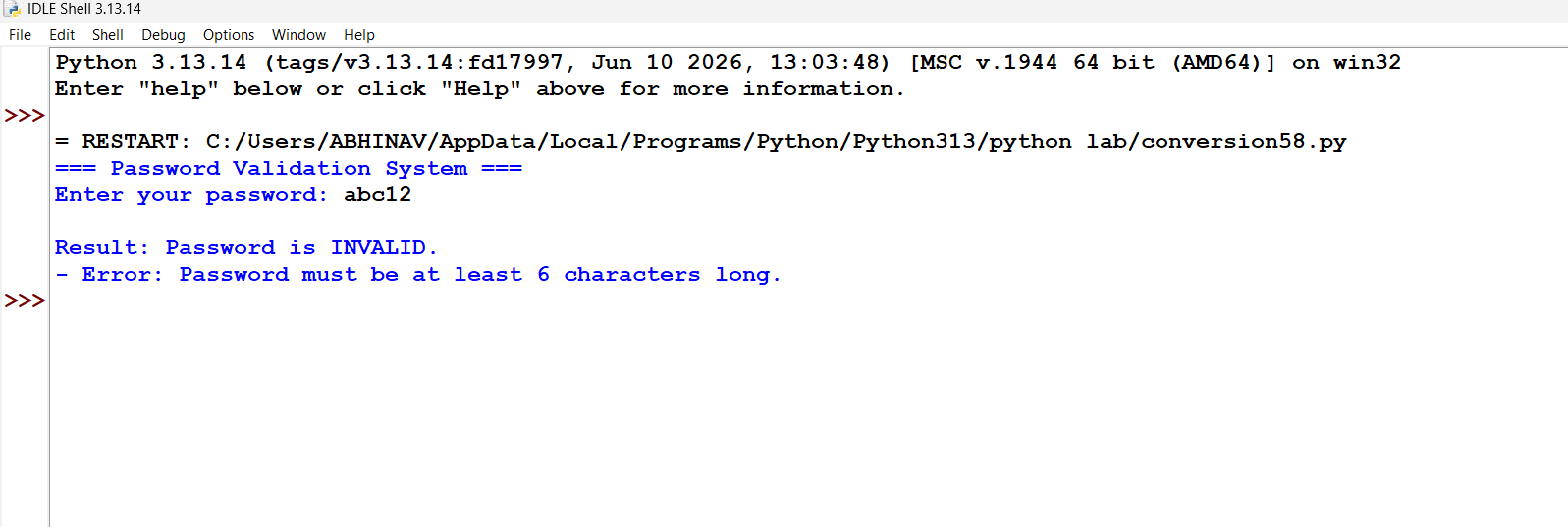
Conclusion: Successfully implemented a string evaluation tool using basic loops and condition checks to verify password length requirements and character constraints.

